**HR METRICS AND ANALYTICS FOR WATCHOUT WATCHES**

**(WATCH COMPANY)**

Submitted by

Hansa A S

M Sc Decision and Computing Sciences III rd year

71762133015

Submitted to

Dr.R.Umarani

Dr.S.Chandia

Department of Decision and Computing Sciences



**COIMBATORE INSTITUTE OF TECHNOLOGY**

**(Government Aided Autonomous Institution)**

**Coimbatore-641014**

**October – 2023**

Table of Contents

1. Introduction to the Company- WatchOut Watches

2. PROJECT SUMMARY

1.1 Project Objective

1.2 Scope of Project

3. FINDINGS AND STRATEGY MAP

4. HR OBJECTIVES WITH KEY QUANTIFIABLE MEASURES

4.1 Culture

4.2 Competency

4.3 Cost and Productivity

4.4 Recruitment

4.5 Training and development

4.5 Performance

4.6 Talent

5. Operational Analytics

6. Conclusion

1. **Introduction to the Company- WatchOut Watches**

WatchOut Watches is an famous watch company with employee strength of about 150 people globally, succeeded in having providing their services to employees of their customers, which are Indian based production company.With their innovative and niche tools and technology, they try to provide all assistance to employees on site, where major need of watch is concerned.

1. **PROJECT SUMMARY**

1.1. Project Objective

The objective of this project is to outline the findings based on problems and areas of focus in WatchOut Watches and suggest needed HR improvements and initiatives to use to be carried by WatchOut Watches in order to achieve its goals.

1.2. Scope of Project

● Findings and WatchOut Watches strategy map based on given case study

● High level guidelines to carry the following HR improvements and initiatives and suggested metrics to use:

* Culture
* Competency
* Cost and productivity
* Recruitment
* Training and development
* Performance
* Talent

● Operational analytics

1. **FINDINGS AND STRATEGY MAP**

FINDINGS:

* Market Research Findings:
* Target Demographics:Our primary customer demographic comprises individuals aged 25 to 55, with a slightly higher preference among males. They value quality, style, and affordability in their wristwatches.
* Competitive Landscape: Our main competitors in the mid-range watch market include brands like Seiko, Citizen, and Casio. They offer a diverse range of products with various features and styles.
* Consumer Preferences:Customers are increasingly interested in watches that incorporate both traditional craftsmanship and modern technology. There's a growing demand for sustainable materials and eco-friendly production processes.
* Product Development Findings:
* Materials: Stainless steel and genuine leather remain the preferred materials for watch cases and bands. Exploring sustainable materials, like recycled metals and vegan leather alternatives, could align with consumer trends.
* Design Trends: Classic and minimalist designs continue to be popular, but there's also a demand for bold and distinctive watch designs that cater to niche markets.
* Technology Integration: The integration of smartwatch features, such as fitness tracking and smartphone connectivity, presents an opportunity for growth and diversification.
* Marketing and Sales Findings:
* Online Presence: An effective online presence is crucial. Our e-commerce platform needs to be user-friendly, and our social media engagement should be consistent to increase brand visibility and customer engagement.
* Customer Experience: Providing exceptional customer service, including responsive support and clear warranty policies, can significantly enhance customer loyalty and satisfaction.
* Retail Strategy: A hybrid approach involving both online and brick-and-mortar retail partnerships can help us reach a broader audience and increase accessibility.
* Financial Findings:
* Revenue Growth: Over the past three years, our company has achieved steady revenue growth, with a CAGR of 10%. Sales have been consistently strong, especially during holiday seasons.
* Cost Management: Identifying cost-effective manufacturing and supply chain optimization strategies has allowed us to maintain healthy profit margins.
* Investment Opportunities: To support future expansion and product development, we may consider seeking additional funding or exploring strategic partnerships.

STRSTEGIC MAP:

Shareholder Perspective

Consistent revenue growth

Financial Perspective

Revenue growth

Cost optimization

Customer Perspective

Excellent customer service

Customer satisfaction

Brand recognition

Business Perspective

Customer life time value

Market share

Quality assurance

Learning and Growth Perspective

Culture

Talent management

Competency

Learning and development

Cost and productivity

Being the no.1 watch brand

1. **HR OBJECTIVES WITH KEY QUANTIFIABLE MEASURES**

Although WatchOut Watches has determined the HR focus area that it needs to work on, they could add some additional initiatives and improvements since they serve as prerequisites to what WatchOut Watches would like to do.

4.1 Culture

WatchOut Watches should work on the organizational culture by inculcating its beliefs, practices and values. This would create feelings of belongingness among the employees and make the workplace a more comfortable one. WatchOut should also make sure that employees understand the culture elements like values and ideologies. However, changing culture tends to be gradual and should be revamped very carefully.

WatchOut Watches should introduce and track the following Key Culture Metrics:

|  |  |  |  |
| --- | --- | --- | --- |
| **Objective** | **HR Measure** | **Target** | **Initiatives** |
| Enhance overall employee satisfaction | Employee engagement survey scores | Increase by 90% | Implement regular feedback mechanisms, recognition programs, and wellness initiatives |
| Promote diversity and inclusivity | Diversity in key roles (gender, ethnicity) | Increase by 100 points | Launch diversity recruitment programs, unconscious bias training, and inclusion workshops. |
| Foster a culture of continuous learning | Average training hours per employee | Increase by 80% | Expand e-learning opportunities, mentorship programs, and skill-building workshops |
| Encourage cross-functional teamwork | Cross-functional project participation | Increase by 85% | Facilitate regular cross-departmental collaborations and team-building activities. |
| Improve internal communication | Employee feedback on communication | 90% satisfaction | Enhance internal communication channels, conduct communication skills training |

4.1.1 EmployeeEngagement or Satisfaction Rating– Increase employee satisfaction with thecompany culture.

4.2 Competency

Competency ensures that the company's employees, especially those involved in watch design, manufacturing, and quality control, possess the necessary skills and knowledge to produce high-quality timepieces. This is essential to meet customer expectations and maintain the company's reputation for excellence.

|  |  |  |  |
| --- | --- | --- | --- |
| **Objective** | **HR Measure** | **Target** | **Initiatives** |
| Ensure employees have necessary skills | Skills assessment and training records | 100% employees trained | Implement ongoing technical training programs. |
| Enhance employees' understanding of watches | Product knowledge assessments | 90% passing rate | Develop comprehensive product knowledge modules. |
| Improve precision and accuracy in watch assembly | Defect rates and quality audits | Reduce defects by 90% | Implement stricter quality control protocols. |
| Enhance employees' ability to troubleshoot and innovate | Problem-solving competency assessments | 95% proficiency | Conduct problem-solving workshops and exercises. |
| Develop leadership capabilities within the organization | Leadership 360-degree assessments | 80% of managers rated highly effective | Launch leadership development programs. |
| Foster adaptability to industry changes | Adaptability and change management assessments | 85% adaptation rate | Provide change management training and resources. |

4.2.1 Insights

4.2.1.1 BARS - Improve the BARS level of staffs with maximum under Level 3 and Level 4.

4.2.1.2 HCRI - Improve the HCRI of the employees from 86% to 90%.

4.3 Cost and productivity

Maintaining control over costs allows the company to offer competitive prices for its watches. In a competitive market, consumers often compare prices before making a purchase, so pricing competitiveness can directly impact sales and market share. Effective cost management contributes to higher profitability. By minimizing unnecessary expenses and optimizing production processes, a watch company can maximize its profit margins, ensuring long-term financial stability and growth.

|  |  |  |  |
| --- | --- | --- | --- |
| **Objective** | **HR Measure** | **Target** | **Initiatives** |
| Control manufacturing costs | Cost analysis and budget adherence | Reduce cost per unit by 90% | Implement lean manufacturing and cost-saving measures. |
| Improve workforce efficiency | Labor productivity metrics | Increase productivity by 85% | Provide training and tools for process optimization. |
| Enhance supply chain performance | Supply chain KPIs and lead times | Reduce lead times by 50 days | Streamline supply chain processes and vendor management. |
| Optimize inventory management | Inventory turnover rate | Increase turnover rate to 1M | Implement just-in-time inventory and demand forecasting. |
| Minimize production interruptions | Downtime tracking and analysis | Reduce downtime by 70% | Conduct preventive maintenance and improve equipment. |

4.3.2 Cost and Productivity

4.3.3.1 Attrition Rate- To understand trends of employees leaving in the year

4.3.3.2 Average Years of Stay- To analyze average tenure of employees

4.3.3.3 Turnover Rate- To understand the number of leavers against joiners

4.4 Recruitment:

It is important for watchOut Watches to assess the skill sets and motivation of a candidate before hiring to reduce attrition within the organization. Along with their alignment to the role, WatchOut also needs to understand the learning curve and career aspirations before hiring.

WatchOur needs to look into their hiring methods and devise strategies to ensure they make the right hires. They can introduce and track the following Key Recruitment Metrics:

|  |  |  |  |
| --- | --- | --- | --- |
| **Objective** | **HR Measure** | **Target** | **Initiatives** |
| Reduce time required to fill open positions | Average time from job posting to offer acceptance | Reduce time by 90% | Streamline the recruitment process, use applicant tracking systems (ATS), and optimize job descriptions. |
| Control recruitment costs | Total recruitment expenses per hire | Decrease cost per hire by 89% | Review and optimize recruitment channels, negotiate with vendors, and reduce reliance on costly sources. |
| Attract and retain top talent | Employee performance assessments | Increase the percentage of top performers hired | Refine job descriptions, enhance screening techniques, and implement competency-based interviews. |
| Enhance the candidate experience | Candidate feedback and satisfaction surveys | Achieve a satisfaction score of 75 | Improve communication, provide timely feedback, and offer a positive interview experience. |
| Promote diversity and inclusion | Diversity metrics (gender, ethnicity, etc.) | Increase diversity by 99% | Implement diversity-focused recruitment strategies, partnerships, and training. |

Insights:

4.3.1 Effective Mode of Hiring- Analyzing all modes of hiring and separation rate in each

4.5 Training and Development:

It is important to help employees reach their personal and professional goals in order to create a strong talent pool. WOW should extensively work on understanding Learning and Development plans of employees to ensure their long tenure with the company. Human Resources should coordinate with department/ managers to plan effective and useful training/workshops for relevant employees based on performance and roles.

The learning and development provided to employees should focus on the core competencies and skills.

|  | **Objective** | **HR Measure** | **Target** | **Initiatives** |
| --- | --- | --- | --- | --- |
|  | Enhance employees' skills and knowledge | Total training hours provided | Increase training hours by 96% | Offer a diverse range of training programs and courses. |
|  | Improve employee competencies and capabilities | Pre- and post-training skills assessments | Achieve a post-training improvement rate of 70% | Implement regular skills assessments and personalized development plans. |
|  | Optimize training investments | Training expenses per employee | Decrease training costs by 86% | Leverage cost-effective e-learning solutions and negotiate training vendor contracts. |
|  | Validate employee expertise | Number of employees certified | Increase the certification rate to 94% | Provide support and resources for certification exam preparation. |
|  | Enhance employee satisfaction and engagement | Training satisfaction surveys | Achieve a satisfaction score of 80 | Collect feedback and make improvements based on employee input. |

4.5.1 Training Hours per employee- Time invested by the organization for an employee’s training and development

4.6 Performance:

WOW should set strategic performance standards for each position including personal performance goals that are aligned with company goals. This will help WOW identify high-performers.

|  | **Objective** | **HR Measure** | **Target** | **Initiatives** |
| --- | --- | --- | --- | --- |
|  | Enhance employees' skills and knowledge | Total training hours provided | Increase training hours by 76% | Offer a diverse range of training programs and courses. |
|  | Improve employee competencies and capabilities | Pre- and post-training skills assessments | Achieve a post-training improvement rate of 90% | Implement regular skills assessments and personalized development plans. |
|  | Optimize training investments | Training expenses per employee | Decrease training costs by 90% | Leverage cost-effective e-learning solutions and negotiate training vendor contracts. |
|  | Validate employee expertise | Number of employees certified | Increase the certification rate to 80% | Provide support and resources for certification exam preparation. |
|  | Enhance employee satisfaction and engagement | Training satisfaction surveys | Achieve a satisfaction score of 75 | Collect feedback and make improvements based on employee input. |

4.7 Talent

To have a strong and stable workforce, WatchOut Watches should motivate and retain talent. They need people who are talented individuals looking to stabilize their career in this segment. This will help WatchOut Watches to identify key performers and roles and improve processes including customer support, quality management, and product design; and accordingly achieve high level of customer satisfaction which will lead to business growth and financial efficiency. WatchOut Watches should introduce and track the following “Talent Management” metrics:

|  |  |  |  |
| --- | --- | --- | --- |
| **Objective** | **HR Measure** | **Target** | **Initiatives** |
| Retain top talent and reduce turnover | Annual turnover rate | Reduce turnover rate to 90% | Conduct exit interviews, implement retention programs, and improve work-life balance initiatives |
| Develop a pool of future leaders | Succession planning metrics | Maintain 70% of critical positions with identified successors | Create and maintain succession plans for key roles. |
| Identify and develop high-potential employees | High-potential program participation | Increase participation by 80% | Launch high-potential development programs and mentorship opportunities. |
| Ensure timely replacement of key positions | Time-to-fill for critical roles | Reduce time-to-fill to 50 days | Establish a streamlined recruitment process for critical roles. |
| Assess and address skill gaps | Skill assessment and development plans | Reduce the number of skill gaps by 80% | Provide targeted training and development programs based on skill assessments. |

1. **Operational Analytics**

Culture:

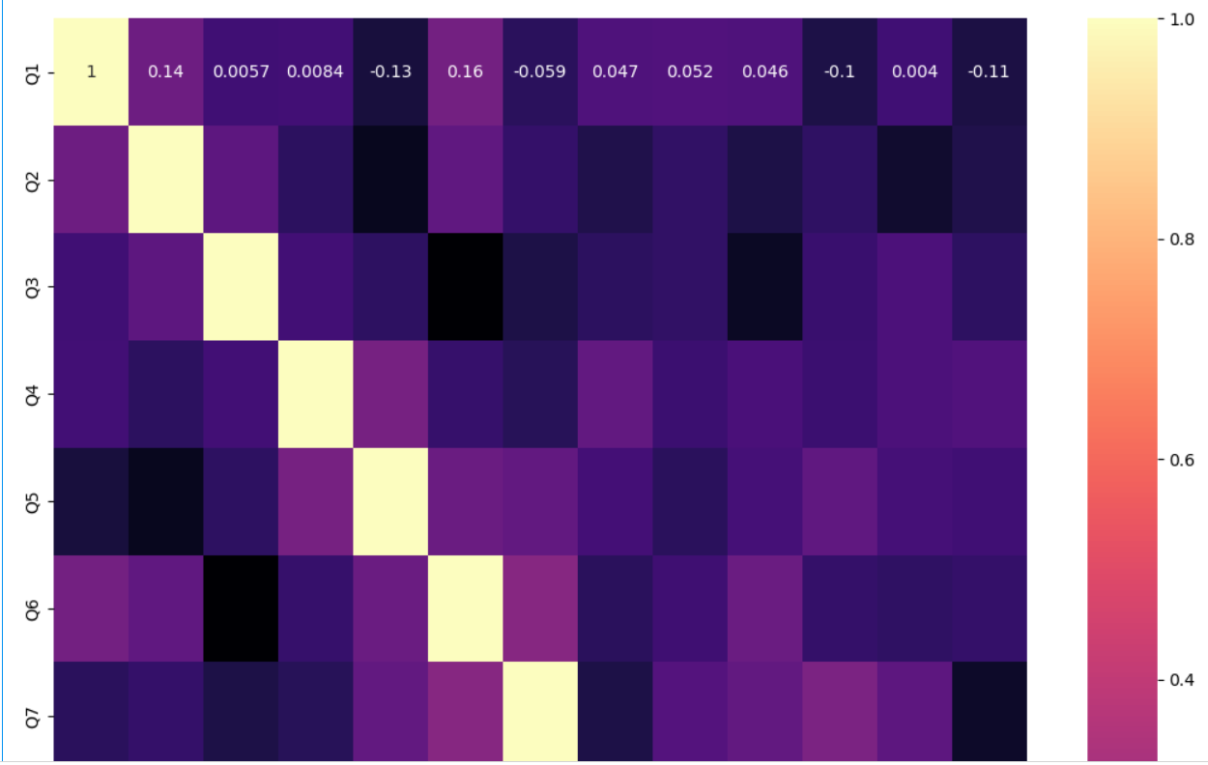]

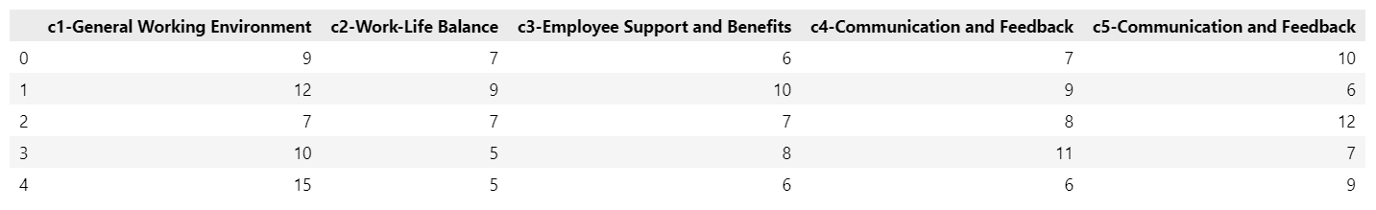

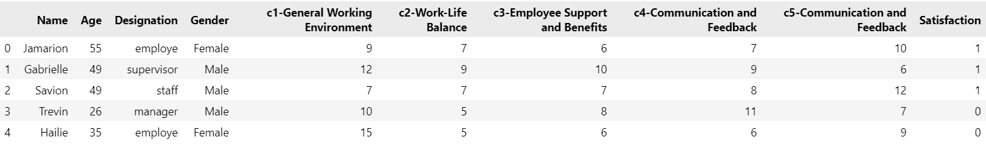

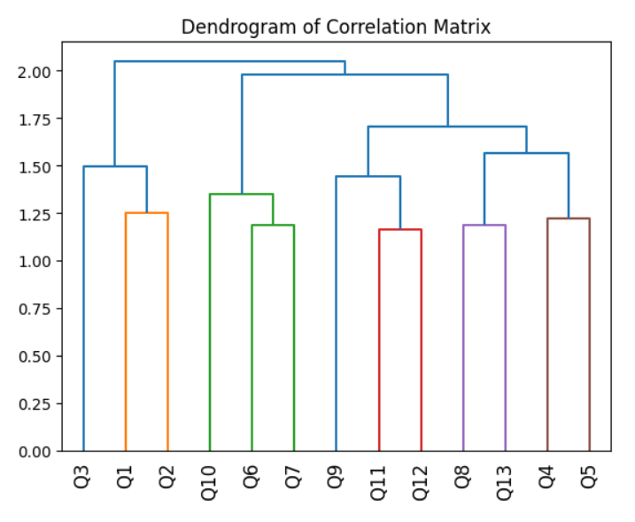



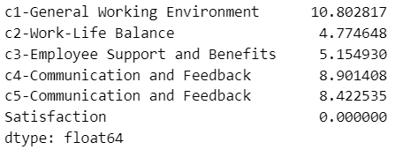

Competency:

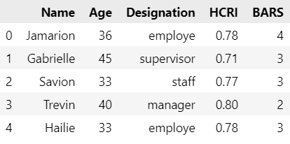

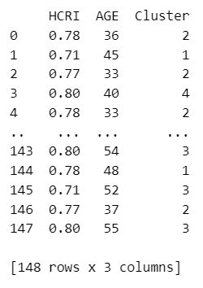 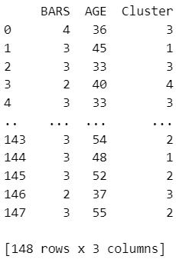

Cost and productivity:

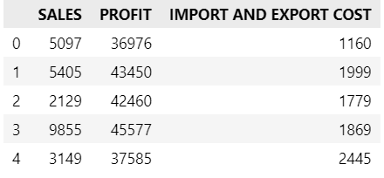 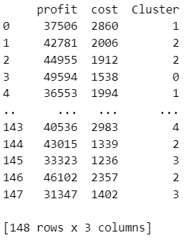

Recruitment:

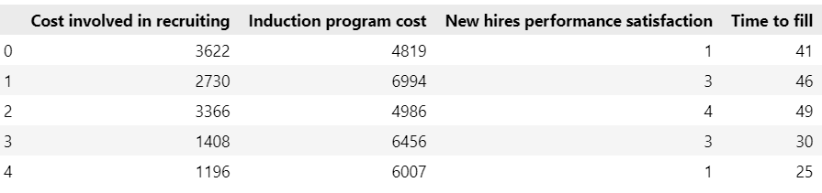

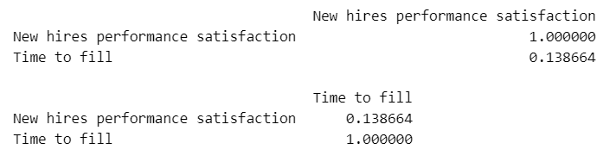

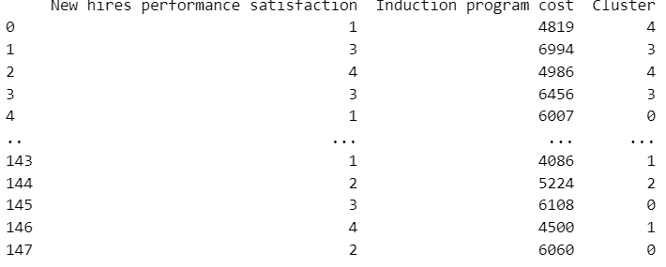

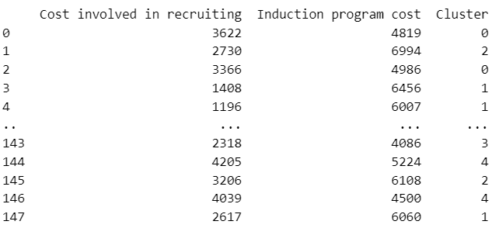

Training and development:

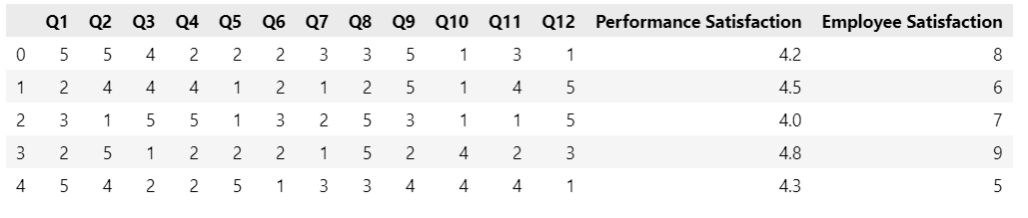

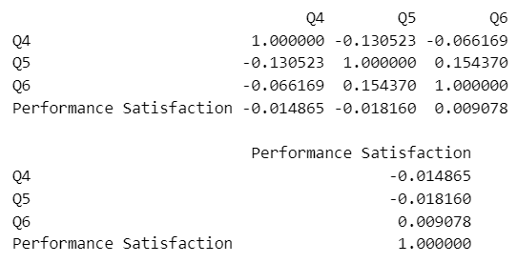

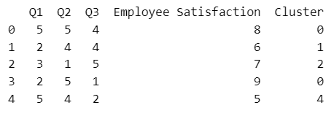

Performance:

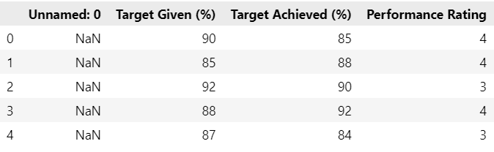

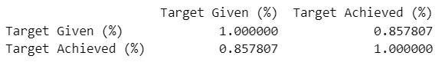

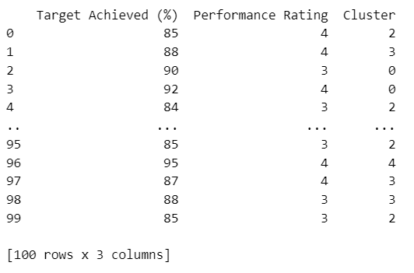

Talent management:

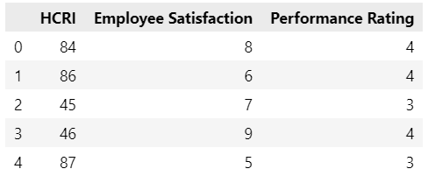

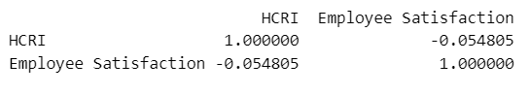

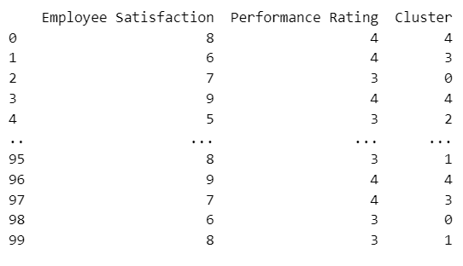

1. **Annexture:**

Culture:

import numpy as np

import pandas as pd

from matplotlib import pyplot as plt

import pandas_datareader as data

import seaborn as sns

df = pd.read_csv("C:/Users/19295/Downloads/ex-3.csv")

df.head()

df.info()

df.describe()

df=df.drop(['Name','DOB','EmployeeType','Gender','E-Mail'],axis=1)

df.head()

corr = df.corr()

plt.figure(figsize = (20 ,10))

sns.heatmap(corr, annot=True, cmap='YlGnBu')

plt.show()

selected_features = ['Q1','Q2','Q3','Q4','Q5','Q6','Q7','Q8','Q9','Q10','Q11','Q12','Q13','Q14','Q15']

from sklearn.preprocessing import StandardScaler

scaler = StandardScaler()

scaled_data = scaler.fit_transform(df[selected_features])

from sklearn.cluster import KMeans

k = 2

n_init = 10

kmeans = KMeans(n_clusters=k, random_state=42, n_init=n_init)

kmeans.fit(scaled_data)

print(scaled_data)

df['Cluster'] = kmeans.labels_

df

from sklearn.decomposition import PCA

data = df[['Q1','Q2','Q3','Q4','Q5','Q6','Q7','Q8','Q9','Q10','Q11','Q12','Q13','Q14','Q15']]

pca = PCA(n_components=2)

data_pca = pca.fit_transform(data)

plt.scatter(data_pca[df['Cluster'] == 0][:, 0], data_pca[df['Cluster'] == 0][:, 1], label='Cluster 0', c='green')

plt.scatter(data_pca[df['Cluster'] == 1][:, 0], data_pca[df['Cluster'] == 1][:, 1], label='Cluster 1', c='yellow')

plt.xlabel('Principal Component 1')

plt.ylabel('Principal Component 2')

plt.title('Scatter Plot of Clusters (K=2) for PCA Components 1 and 2')

plt.legend()

plt.show()

competency:

import pandas as pd

import seaborn as sns

import matplotlib.pyplot as plt

import numpy as num

df=pd.read_excel("C:\\Users\\New Pc\\Documents\\EX.7.xlsx",sheet_name="Sheet2")

df.head()

df.dtypes

df_1= df[['HCRI','BARS']]

cor = df_1.corr()

print(cor.head())

df.isnull().sum()

df.count()

from sklearn.cluster import KMeans

from sklearn.preprocessing import StandardScaler

profit=df['HCRI'].values

cost=df['Age'].values

feat=num.column_stack((profit,cost))

model=KMeans(n_clusters=5,n_init=10)

model.fit(feat)

label = model.predict(feat)

cluster_centers = model.cluster_centers_

df['cluster']=label

cluster_df = pd.DataFrame({

    'HCRI': df['HCRI'],

    'AGE': df['Age'],

    'Cluster': df['cluster']

})

print(cluster_df)

profit=df['BARS'].values

cost=df['Age'].values

feat=num.column_stack((profit,cost))

model=KMeans(n_clusters=5,n_init=10)

model.fit(feat)

label = model.predict(feat)

cluster_centers = model.cluster_centers_

df['cluster']=label

cluster_df = pd.DataFrame({

    'BARS': df['BARS'],

    'AGE': df['Age'],

    'Cluster': df['cluster']

})

print(cluster_df)

cost and productivity

import pandas as pd

import seaborn as sns

import matplotlib.pyplot as plt

import numpy as num

df=pd.read_excel("C:\\Users\\New Pc\\Documents\\EX.7.xlsx",sheet_name="Sheet2")

df.head()

df.dtypes

df_1= df[['SALES','PROFIT']]

cor = df_1.corr()

print(cor.head())

df.isnull().sum()

df.count()

from sklearn.cluster import KMeans

from sklearn.preprocessing import StandardScaler

profit=df['PROFIT'].values

cost=df['IMPORT AND EXPORT COST'].values

feat=num.column_stack((profit,cost))

model=KMeans(n_clusters=5,n_init=10)

model.fit(feat)

label = model.predict(feat)

cluster_centers = model.cluster_centers_

df['cluster']=label

cluster_df = pd.DataFrame({

    'profit': df['PROFIT'],

    'cost': df['IMPORT AND EXPORT COST'],

    'Cluster': df['cluster']

})

print(cluster_df)

Recruitment

import pandas as pd

import seaborn as sns

import matplotlib.pyplot as plt

import numpy as num

df=pd.read_excel("C:\\Users\\New Pc\\Documents\\EX.7.xlsx",sheet_name="Sheet2")

df.head()

df.dtypes

df_1= df[['New hires performance satisfaction','Time to fill']]

cor = df_1.corr()

print(cor.head())

df.isnull().sum()

df.count()

from sklearn.cluster import KMeans

from sklearn.preprocessing import StandardScaler

profit=df['New hires performance satisfaction'].values

cost=df['Induction program cost'].values

feat=num.column_stack((profit,cost))

model=KMeans(n_clusters=5,n_init=10)

model.fit(feat)

label = model.predict(feat)

cluster_centers = model.cluster_centers_

df['cluster']=label

cluster_df = pd.DataFrame({

    'New hires performance satisfaction': df['New hires performance satisfaction'],

    'Induction program cost': df['Induction program cost'],

    'Cluster': df['cluster']

})

print(cluster_df)

profit=df['Cost involved in recruiting'].values

cost=df['Induction program cost'].values

feat=num.column_stack((profit,cost))

model=KMeans(n_clusters=5,n_init=10)

model.fit(feat)

label = model.predict(feat)

cluster_centers = model.cluster_centers_

df['cluster']=label

cluster_df = pd.DataFrame({

    'Cost involved in recruiting': df['Cost involved in recruiting'],

    'Induction program cost': df['Induction program cost'],

    'Cluster': df['cluster']

})

Training and Development

import pandas as pd

import seaborn as sns

import matplotlib.pyplot as plt

import numpy as num

df=pd.read_excel("C:\\Users\\New Pc\\Documents\\EX.7.xlsx",sheet_name="Sheet2")

df.head()

df.dtypes

df_1=df[['Q4','Q5','Q6','Performance Satisfaction']]

cor = df_1.corr()

print(cor.head())

df.isnull().sum()

df.count()

from sklearn.cluster import KMeans

from sklearn.preprocessing import StandardScaler

hcri=df[['Q1','Q2','Q3']].values

age=df['Employee Satisfaction'].values

feat=np.column_stack((hcri,age))

model=KMeans(n_clusters=5,n_init=10)

model.fit(feat)

label = model.predict(feat)

cluster_centers = model.cluster_centers_

df['Cluster'] = label

cluster_df = pd.DataFrame({

    'Q1': df['Q1'].values,

    'Q2': df['Q2'].values,

    'Q3': df['Q3'].values,

    'Employee Satisfaction': df['Employee Satisfaction'],

    'Cluster': df['Cluster']

})

print(cluster_df.head())

Performance

import pandas as pd

import seaborn as sns

import matplotlib.pyplot as plt

import numpy as num

df=pd.read_excel("C:\\Users\\New Pc\\Documents\\EX.7.xlsx",sheet_name="Sheet2")

df.head()

df.dtypes

df_1=df[['Target Given (%)','Target Achieved (%)']]

cor = df_1.corr()

print(cor.head())

df.isnull().sum()

df.count()

from sklearn.cluster import KMeans

from sklearn.preprocessing import StandardScaler

hcri=df['Target Achieved (%)'].values

age=df['Performance Rating'].values

feat=np.column_stack((hcri,age))

model=KMeans(n_clusters=5,n_init=10)

model.fit(feat)

label = model.predict(feat)

cluster_centers = model.cluster_centers_

df['Cluster'] = label

cluster_df = pd.DataFrame({

    'Target Achieved (%)': df['Target Achieved (%)'],

    'Performance Rating': df['Performance Rating'],

    'Cluster': df['Cluster']

})

print(cluster_df)

Talent

import pandas as pd

import seaborn as sns

import matplotlib.pyplot as plt

import numpy as num

df=pd.read_excel("C:\\Users\\New Pc\\Documents\\EX.7.xlsx",sheet_name="Sheet2")

df.head()

df.dtypes

df_1=df[['HCRI','Employee Satisfaction']]

cor = df_1.corr()

print(cor.head())

df.isnull().sum()

df.count()

from sklearn.cluster import KMeans

from sklearn.preprocessing import StandardScaler

hcri=df['Employee Satisfaction'].values

age=df['Performance Rating'].values

feat=np.column_stack((hcri,age))

model=KMeans(n_clusters=5,n_init=10)

model.fit(feat)

label = model.predict(feat)

cluster_centers = model.cluster_centers_

df['Cluster'] = label

cluster_df = pd.DataFrame({

    'Employee Satisfaction': df['Employee Satisfaction'],

    'Performance Rating': df['Performance Rating'],

    'Cluster': df['Cluster']

})

print(cluster_df)

1. **Conclusion**

WOW is a growing firm which needs to work on its HR processes from time to time. As the ‘Peoples’ Department, HGS needs to pay more attention to the feedback provided by its employees and devise strategic plans which suit the employees and the organization.

Throughout this project, we have achieved several key outcomes:

1. Enhanced Talent Acquisition: Our revamped recruitment processes have allowed us to attract top-tier talent, ensuring that we have the right people in the right roles to drive innovation and excellence within the company.
2. Employee Development: Our investments in training and development programs have not only upskilled our workforce but also contributed to higher levels of employee engagement and satisfaction.
3. Improved Employee Engagement: Initiatives aimed at promoting a healthy work-life balance, recognizing and rewarding employee contributions, and fostering open communication have resulted in increased employee morale and commitment.
4. Streamlined HR Operations: The automation and digitization of HR processes have led to greater efficiency, reduced administrative burdens, and improved accuracy in HR management.
5. Diversity and Inclusion: Our commitment to diversity and inclusion has not only made our workplace more equitable and representative but has also driven innovation and creativity within our teams.
6. Employee Wellbeing: Our wellness programs and initiatives have demonstrated our dedication to the physical and mental health of our employees, contributing to a more resilient and productive workforce.

---------- End of Project---------------